PROJECT TITLE:
Phishing & Packet Analysis Training Platform
R.Shravan Kumar SHASHIDHAR
CYBERSECURITY CYBER SECURITY TRAINER
TAH30088251802 TEKS ACADEMY
TEKS ACADEMY 9603343287

Abstract:
The Phishing & Packet Analysis Training Platform is an interactive web application designed to educate users on the critical skills of phishing detection and network intrusion analysis. By providing a safe, controlled environment, the platform allows users to analyze simulated network packet captures and email communications to identify malicious indicators. Built using Vite, React, and TypeScript, the project focuses on a dynamic, modern front-end experience. This tool aims to lower the learning curve for cybersecurity fundamentals, providing practical, hands-on training for students, professionals, and enthusiasts.

Problem Statement:
Training materials for cybersecurity, particularly in the areas of phishing and packet analysis, often rely on static presentations or require complex setup of virtual lab environments. This complexity hinders accessibility and real-world applicability for many learners. There is a need for a streamlined, web-based platform that offers hands-on, gamified analysis of simulated data (like email headers and packet capture files) to make the process of learning detection techniques efficient, engaging, and easily accessible without the overhead of system configuration.

Project Objectives:
- Enable users to analyze simulated emails and packet data within a web interface.
- Provide an interactive UI for exploring headers, message bodies, and packet details.
- Clearly present the underlying concepts of phishing and network traffic analysis.
- Develop a robust, type-safe front-end using React and TypeScript.
- Ensure a responsive and modern design using Tailwind CSS.
- Provide a platform that is easy to run and develop locally using Vite.

Project Scope:
- Uses modern front-end technologies: Vite, React, and TypeScript.
- Focuses exclusively on the client-side UI and analysis components.
- No backend service is required for the core training/demo functionality. All data is simulated or hard-coded within the front-end application.
- Designed as a training platform and is not intended for real-time monitoring or deployment in production environments.
- Requires a local Node.js environment for development and running the application.

Tools & Technologies:
- Vite – Fast build tool and development server.
- React – For building the user interface (project/src/components).
- TypeScript – For type safety and improved code quality.
- Tailwind CSS – For utility-first styling (project/postcss.config.js).
- npm/yarn – For dependency management and running scripts.
- ESLint & TypeScript Checks – For code linting and type validation.

Timeline (Tentative):
Week / Day | Task
Day 1 | Set up Vite/React/TS environment and integrate Tailwind CSS.
Day 2 | Develop core Email Analyzer component UI (EmailAnalyzer.tsx).
Day 3 | Develop core Packet Analysis component UI (simulated data view).
Day 4 | Implement utility functions and integrate training scenarios.
Day 5 | Testing, bug fixes, UI/UX polish, and final documentation.

Deliverables:
- A functional web application (project/) for demonstrating phishing and packet analysis.
- Email Analyzer Component for inspecting simulated email headers and content.
- Packet Analysis Component for reviewing simulated network traffic data.
- Clean, well-structured, and type-safe TypeScript/React codebase.
- Clear documentation for running, linting, and building the project.

Project Implementation:

Local Development Success
- Setup: You navigated to the project directory and installed dependencies (npm install).
- Run: You successfully started the development server (npm run dev) and viewed the website on localhost and your local network.
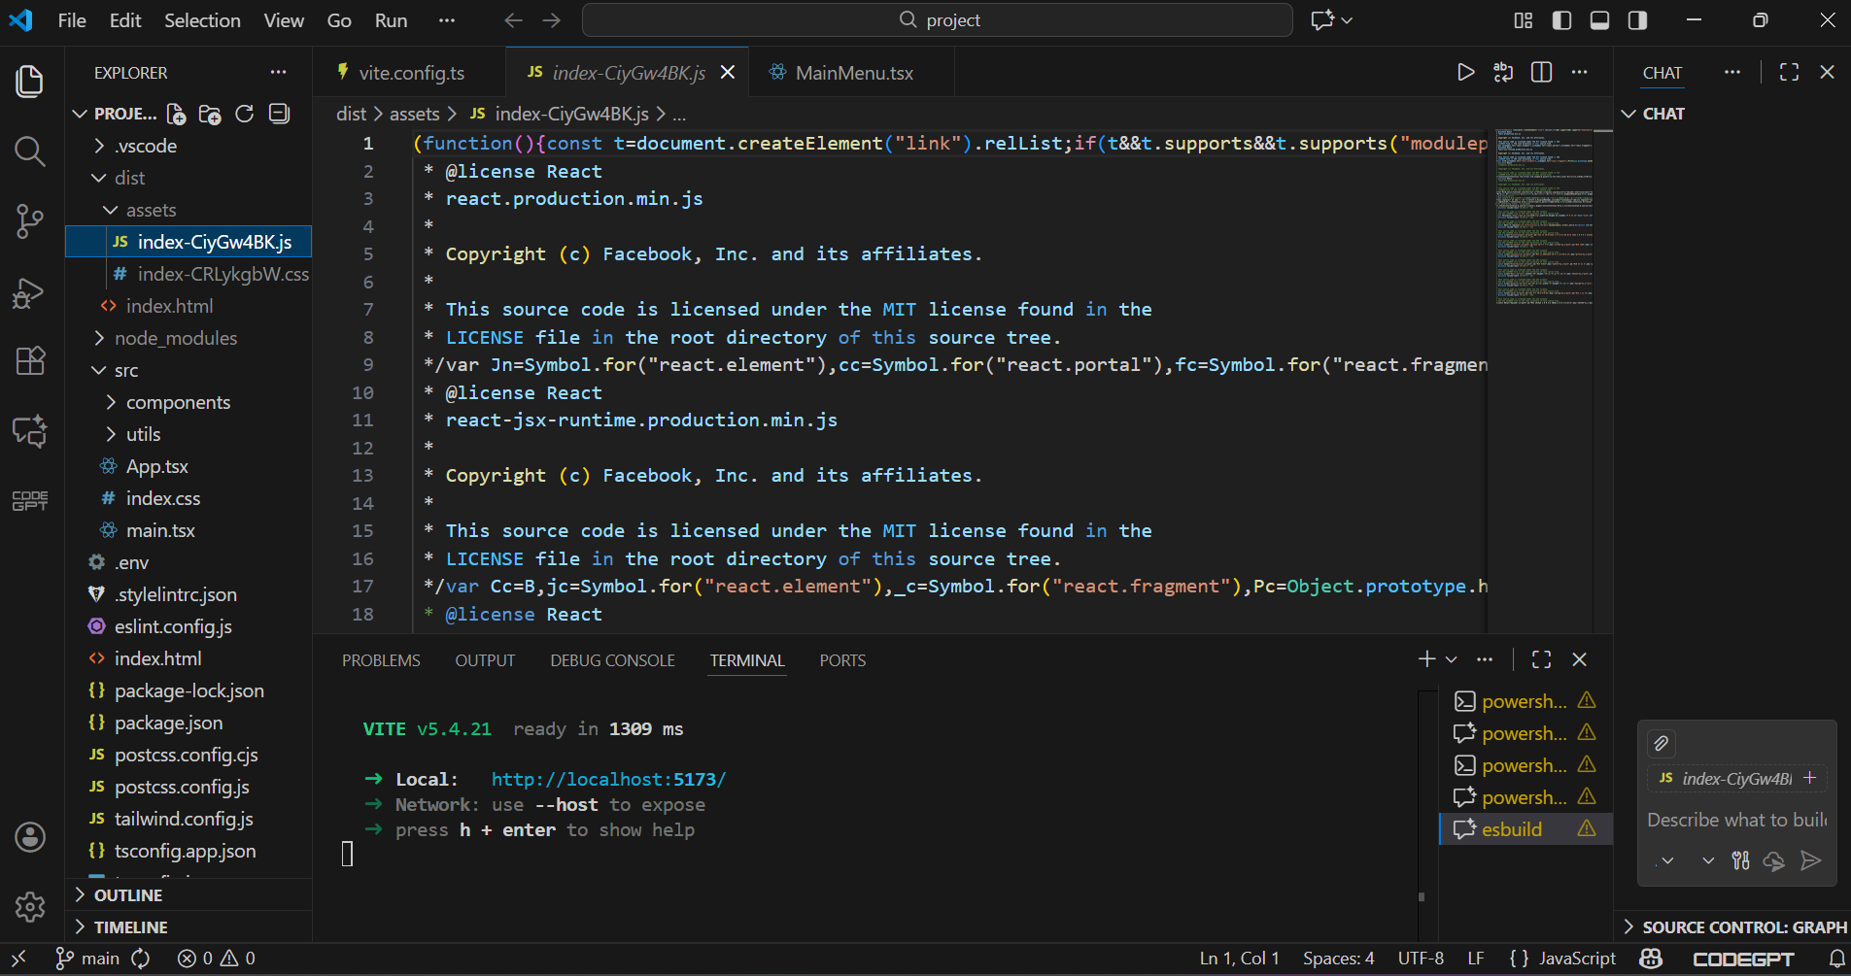

2. Version Control and Hosting
- GitHub Push: Using Git to push the repository to GitHub is crucial for version control and collaboration.
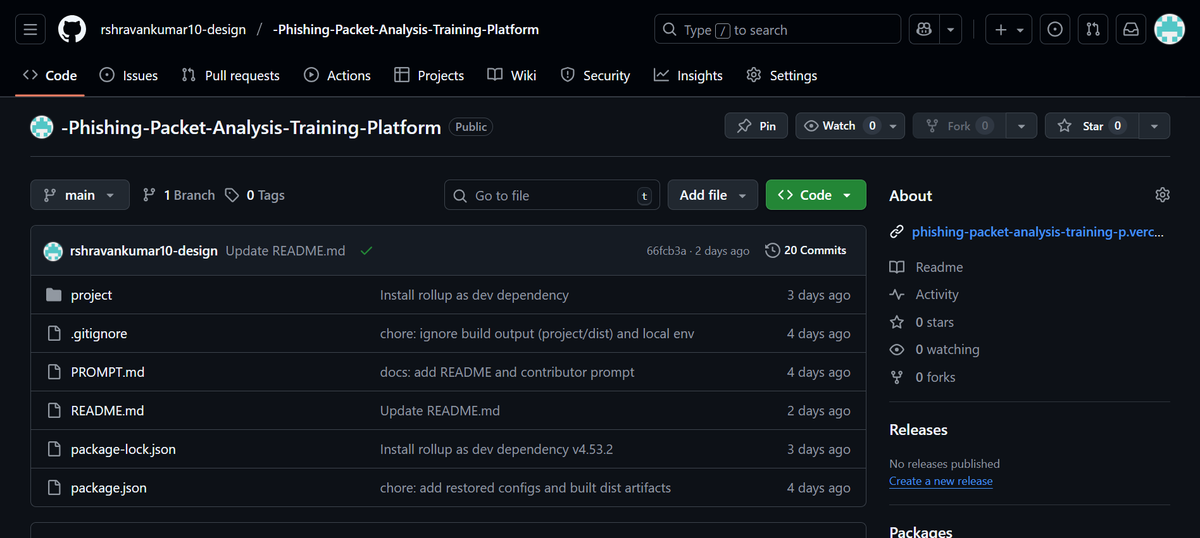
- Vercel Deployment: Deploying the site to Vercel means your training platform is now live and accessible via a public URL, achieving a key project objective of accessibility.
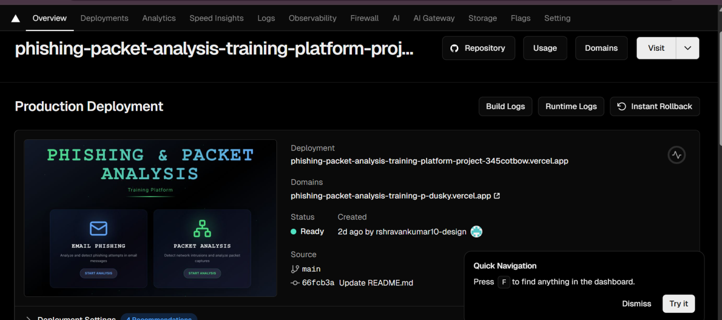

What to Focus on Now
The next focus area should be on content creation and UI implementation, as outlined in the Core Development Steps.


1. UI Development (Building the Core Components)
The platform needs the interactive components that allow users to actually analyze data.
- EmailAnalyzer.tsx: Focus on building this component's UI to allow users to inspect simulated email headers, message bodies, and malicious links.
- Packet Analysis Component: Develop the UI for reviewing simulated network traffic, including tables for source/destination IPs, ports, and payload snippets.
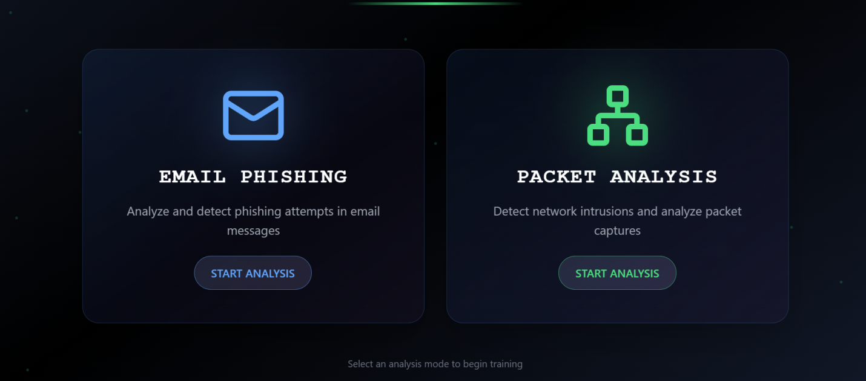

2. Code Quality Assurance (Linting and Type Checking)
Before moving too far, ensure your new code adheres to the project's standards:
- Linting: Regularly run npm run lint to catch stylistic and basic code errors.
- Type Checks: Run npm run typecheck to ensure the new components are type-safe, which is a key goal of using TypeScript.

3. Documentation Update
Since you've deployed, you should update your documentation:
- README/PROMPT.md: Update the files of interest or add a section about the deployment link
- GitHub CLI : gh repo clone rshravankumar10-design/-Phishing-Packet-Analysis-Training-Platform
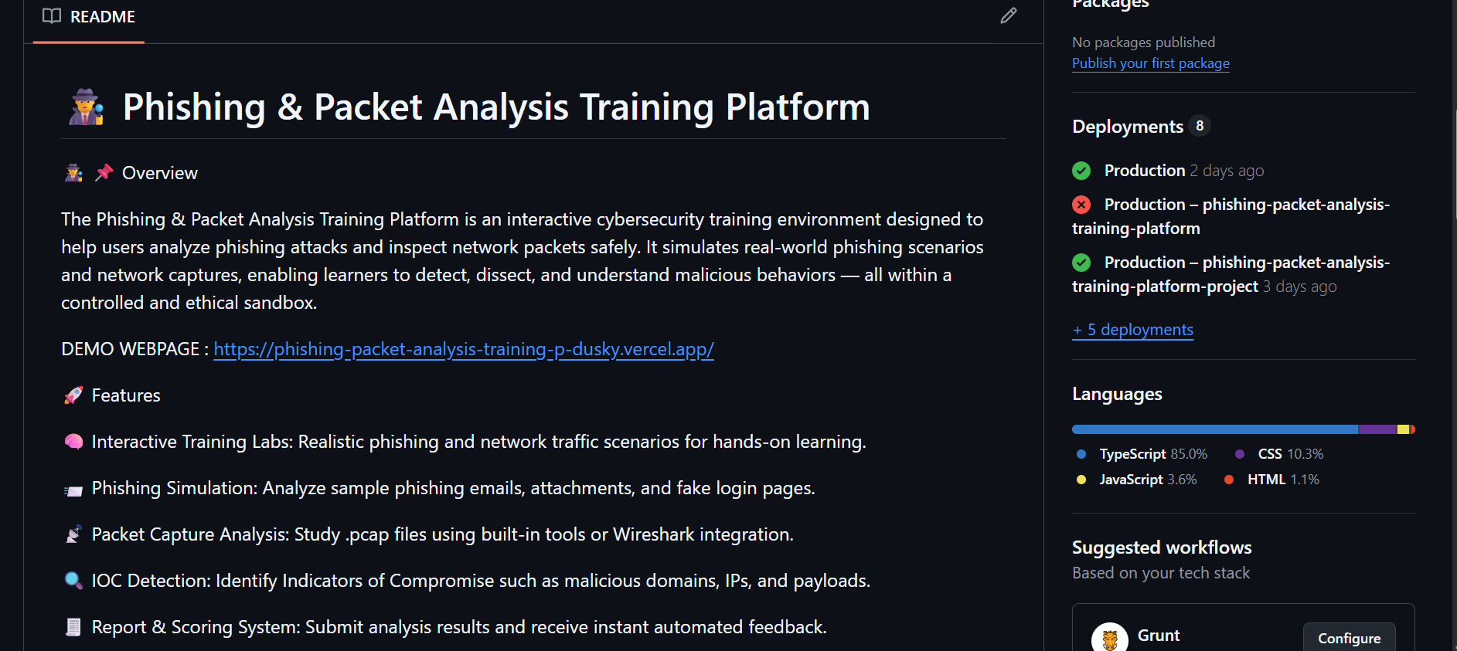

Front-End Implementation:
- The main UI provides components for users to interact with training data.
- Key components include Email Headers View (showing spoofed sender details, etc.) and a Packet Breakdown table (showing source/destination IPs, ports, and payload snippets).
- State Management will be handled by React hooks (e.g., useState, useReducer).
- The application is designed for accessibility and responsiveness using Tailwind CSS.

Usage Example:
- The user selects a training scenario (e.g., "Analyze Malicious Login Email").
- The Email Analyzer loads a simulated phishing email.
- The user examines the 'From' address, 'Reply-To' header, and links in the message body.
- The system provides instant feedback or a score based on the user's identification of malicious indicators.

Limitations & Future Work:
- Limitation: Training data is currently static and simulated within the front-end code.
- Future Work:
  - Integrate a back-end service to load dynamic training scenarios and store user progress.
  - Add a scoring/gamification system to track user performance.
  - Develop an advanced network topology visualization component.
  - Expand language support beyond English.

Conclusion:
The Phishing & Packet Analysis Training Platform achieves its goal of providing an accessible, hands-on tool for cybersecurity education. By leveraging the speed of Vite, the component architecture of React, and the safety of TypeScript, it delivers a modern, robust, and engaging learning experience, preparing users to confidently identify and respond to real-world threats.

Contact
R.Shravan Kumar
[rshravankumar10@gmail.com]

